The First Presbyterian Church

of Port Gibson, Mississippi

Worship Service April 30, A.D. 2017

Instrumental Prelude Mrs. H.N. Gage
Introit The Choir
Welcome and Announcements
The Doxology No. 572
Invocation and Lord’s Prayer
Responsive Reading No. 651
Hymn of Praise (All) No. 224
The Apostles’ Creed (Front of Hymnal)
The Gloria Patri No. 576
Minute for Mission – Quest Church, New Braunfels
Hymn of Meditation (All) No. 517
****
Silent Prayer and Meditation
The Pastoral Prayer
Choral Response
****
Offering and Offertory Prayer
Scripture Ezekiel 37:1-14 (p. 638, p.)
Sermon “Prophesy to the Breath”
Hymn of Dedication (All) No. 249
Benediction
Response The Choir
Postlude

We extend our sincere welcome to our visitors.
Please come to worship with us again, soon.

CHILDREN in second grade or younger are welcome to attend Children’s Church after the Time with God’s Children.

IF YOU DESIRE TO BECOME A MEMBER of this congregation of the
Body of Christ, please speak to the pastor after the Worship Service.

Announcements

WE WELCOME Evangelist Brett Becker, who will tell us about the Presbytery’s church plant in New Braunfels, Texas. For more information, go to www.questchurchnb.com To help, make out your check to First Presbyterian Church and label it “Quest Church.”

A PRAYER BREAKFAST will be held at 6:30am on Wednesday in the Annex.

OUR SPRING GRAND GULF OUTING will be next Sunday,
May 7. Come to the park pavilion at 10:30 for worship, and stay for a covered-dish lunch afterwards.

ALL SOULS’ CHURCH is a presbytery church planting effort in Austin, Texas: http://www.landofmysojourn.com To help, make out your check to First Presbyterian Church and label it “All Souls’ Church.”

PLEASE PRAY for Nick and Amanda, and Nour and Rebecca as they participate in the Engage 2025 project in the Middle East. To help, make out your check to First Presbyterian Church and label it either “Nick and Amanda” or “Nour and Rebecca.”

PLEASE PRAY for Andrew Brunson, an EPC Teaching Elder who has been unjustly imprisoned in Turkey. You can find more information at https://www.epc.org/forgottenamericaninturkey

Opening and Closing Schedule

4/30-5/6 – John L. Torrey 5/28-6/3 – Scott Davis
5/7-13 – Doug Nasif 6/4-10 – Michelle Burrell
5/14-20 – Shreve Guthrie, III 6/11-17 – Kenny Strawn
5/21-27 – Don Wilson 6/18-24 – Eddie Lipscomb
6/25-7/1 – Lem Montgomery

Upcoming Events

May 4-7 Presbyterian Cursillo, Camp Wesley Pines
May 7 Spring Grand Gulf Outing, 10:30am
May 19 PG Heritage Trust Progressive Dinner
May 20 RiverPointe Spring Recital, 2pm and 6pm
June 10 Chamber of Commerce Car Show
June 20-23 EPC General Assembly, Sacramento, CA
September 22-23 Presbytery Meeting, Christ EPC Houston
October 1 Fall Grand Gulf Outing, 10:30am
November 2-5 Presbyterian Cursillo, Camp Wesley Pines
Bible Reading Schedule

May 1 Psalm 139:1-12 – Can I Flee from God’s Presence?
May 2 Psalm 29 – The Lord’s Voice in the Storm
May 3 Isaiah 54:1-10 – Compassion after Rejection
May 4 Nahum 1:1-8 – God’s Wrath against Nineveh
May 5 Nahum 1:9-15 – Nineveh Will Be Destroyed
May 6 Jonah 1:1-6 – Fleeing from God’s Call
May 7 Jonah 1:7-17 – God’s Sustaining Love despite Rebellion

May Birthdays

2 Janice Carter 7 Al Killingsworth
9 Shelton Headley 10 George Hay
11 Lillie Cassell 13 Natalie Cassell
14 Lydia Mae Fraley 15 Cathi Dodgen
17 Scott Harrison 20 Lem Montgomery
21 Ella Daughdrill 22 Alohi Easley
25 E.G. Nations 30 Iliahi Easley
31 Betty Gage

Church Directory

Rev. Michael G. Herrin, Pastor
Mrs. H.N. Gage, Organist

The Session

Class of 2017 Class of 2018 Class of 2019
Mr. Burton O. Byrnes, II Mr. Gary Knight Mr. Kenny Strawn
Mr. Douglas Nasif Mr. Lem Montgomery Mr. John L. Torrey

The Diaconate

Class of 2017 Class of 2018 Class of 2019
Mr. Jimmy Cassell Mr. Jim Hynum Shreve Guthrie, III
Dr. Eddie Lipscomb Mr. Mack May Kevin Keaton
Mr. Mike Mikell

Presbyterian Women

Mrs. Dianne Wade, Moderator Dr. Betsy Lipscomb, Mission Representative
Mrs. Jo Ann Mikell, Vice-Moderator Mrs. Azalea Knight, Secretary/Treasurer

Deacon for the Month: Mack May
Tithes and offerings may be mailed to P.O. Box 517.
CD recordings of services are available. Call the pastor at 5887.

Through fellowship, teaching and service,
sharing the truth of Jesus Christ
with one another, with the community, and with the world.

The First Presbyterian Church

PORT GIBSON, MISSISSIPPI
ORGANIZED 1807
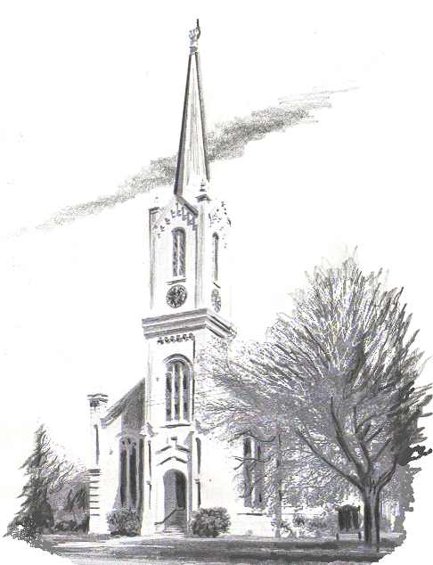

Website: www.fpcportgibson.com Study Telephone: 437-5428
Manse Address: 1101 Church Street Manse Telephone: 437-5887

